

**Experiment 2**

**Student Name:** Yana Srivastava **UID:** 20BCS2279

**Branch:** BE CSE **Section/Group:** 20BCSWM_906 B

**Semester:** 5th  **Date of Performance:** 17.08.2022

**Subject Name:** Problem Based Learning in Java Lab **Subject Code:** 20CSP_321

**1. Aim/Overview of the practical:**

A Video Rental Inventory System

**2. Task to be done/ Which logistics used:**

The goal of this project is to design and implement a simple inventory control system for a small video rental store. Define least two classes: a class Video to model a video and a class VideoStore to model the actual store.

Assume that an object of class Video has the following attributes:

1. A title;
2. a flag to say whether it is checked out or not; and
3. An average user rating.

Add instance variables for each of these attributes to the Video class.

In addition, you will need to add methods corresponding to the following:

1. being checked out;
2. being returned; and
3. receiving a rating.

The VideoStore class will contain at least an instance variable that references an array of videos (say of length 10). The VideoStore will contain the following methods:

1. addVideo(String): add a new video (by title) to the inventory;
2. checkOut(String): check out a video (by title);
3. returnVideo(String): return a video to the store;
4. receiveRating(String, int) : take a user's rating for a video; and
5. listInventory(): list the whole inventory of videos in the store.





Finally, create a VideoStoreLauncher class with a main() method which will test the functionality of your other two classes. It should allow the following.

* 1. Add 3 videos: "The Matrix", "Godfather II", "Star Wars Episode IV: A New Hope".
  2. Give several ratings to each video.
  3. Rent each video out once and return it. List the inventory after "Godfather II" has been rented out

1. **Steps for experiment/practical/Code:**

**import** java.util.Scanner;

**class** Video1

{

String videoName;

**boolean** checkout;

**int** rating;

**public** Video1(String name)

{

videoName=name;

}

**public** String getName()

{

**return** videoName;

}

**public void** doCheckout()

{

System.***err***.println("Video "+'"'+ getName()+'"' +" checked out successfully.");

}

**public void** doReturn()

{

checkout=**true**;

System.***err***.println("Video "+'"'+ getName()+'"' +" returned successfully.");

}

**public void** receiveRating(**int** rating)

{

**this**.rating=rating;

}

**public int** getRating()

{

**return** rating;

}

**public boolean** getCheckout()

{

**return** checkout;

}

}

**class** VideoStore1

{

Video1[] store;

**public** VideoStore1()

{





store=**new** Video1[5];

}

**public void** addVideo(String name)

{

store[0]=**new** Video1(name);

System.***err***.println("Video "+'"'+store[0].getName()+'"'+" added successfully");

}

**public void** doCheckout(String name)

{

**if**(store[0].videoName.equals(name))

{

store[0].doCheckout();

}

}

**public void** doReturn(String name)

{

**if**(store[0].videoName.equals(name))

{

store[0].doReturn();

}

}

**public void** receiveRating(String name, **int** rating)

{

**if**(store[0].videoName.equals(name))

{

store[0].receiveRating(rating);

}

System.***err***.println("Rating "+'"'+store[0].getRating()+'"'+" has been mapped to the

Video ''"+store[0].getName()+'"');

}

**public void** listInventory() {

System.***out***.println("------------------------------------------");

System.***out***.println("Video Name | Checkout Status | Rating");

System.***out***.println(store[0].getName()+"|" +store[0].getCheckout()+ "|"+

store[0].getRating());

System.***out***.println("------------------------------------------");

}

}

**class** VideoStoreLaucher

{

**public static void** main(String[] args)

{

Scanner input=**new** Scanner(System.***in***);

**int** choice;

VideoStore1 videoStore=**new** VideoStore1();

**do** {

System.***out***.println("MAIN MENU \n=========");

System.***out***.println("1. Add Videos:");

System.***out***.println("2. Check Out Video:");

System.***out***.println("3. Return Video:");





System.***out***.println("4. Receive Rating:");

System.***out***.println("5. List Inventory:");

System.***out***.println("6. Exit:");

System.***out***.print("Enter your choice(1..6): ");

choice=input.nextInt();

**switch** (choice) {

**case** 1:

System.***out***.println("Enter the name of the video you want to add: "); videoStore.addVideo(input.next());

**break**;

**case** 2:

System.***out***.print("Enter the name of the video you want to check out:

");

videoStore.doCheckout(input.next());

**break**;

**case** 3:

System.***out***.print("Enter the name of the video you want to Return:"); videoStore.doReturn(input.next());

**break**;

**case** 4:

System.***out***.println("Enter the name of the video you want to Rate: "); videoStore.receiveRating(input.next(), input.nextInt()); **break**;

**case** 5:

videoStore.listInventory();

**break**;

**case** 6:

System.***err***.println("Enter ...!! Thanks for using the application"); System.*exit*(0);

**break**;

}

}**while**(!(choice>=6));

input.close();

}

}

**4. Result/Output/Writing Summary:**



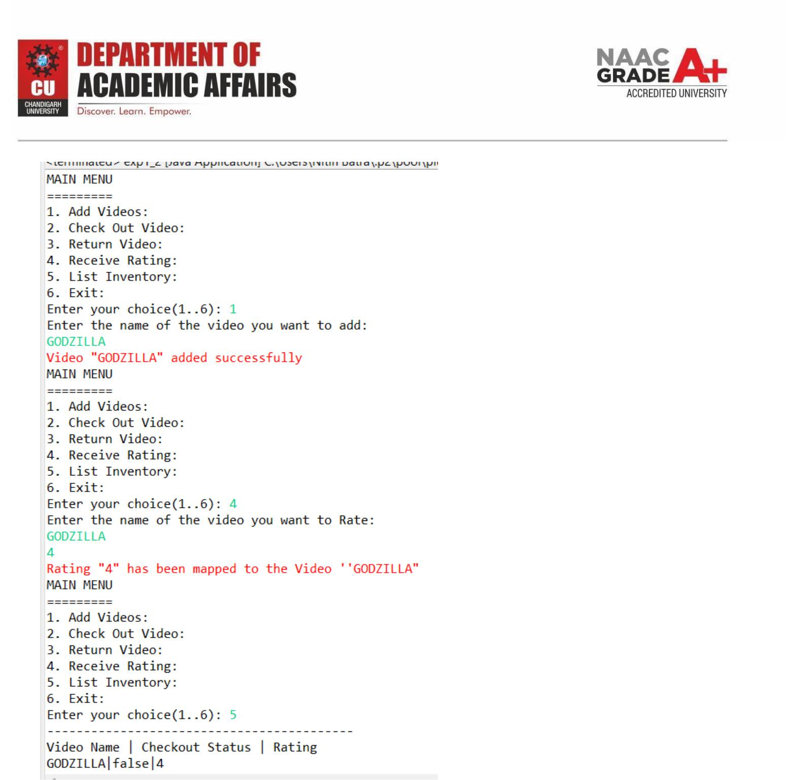





**Learning outcomes (What I have learnt):**

1. Learnt about classes in Java.
2. Learnt about access specifiers in Java.
3. Leant about methods in Java.

**Evaluation Grid (To be created as per the SOP and Assessment guidelines by the faculty):**

|  |  |  |  |
| --- | --- | --- | --- |
| Sr. No. | Parameters | Marks Obtained | Maximum Marks |
| 1. |  |  |  |
| 2. |  |  |  |
| 3. |  |  |  |

